Embedded System Lab

EXPERIMENT 1
C FOR EMBEDDED SYSTEMS

From: M Husnain Khalid
22L-6286

To: Muhammad Ahmad

EXERCISE - 1:
Declare an unsigned char variable x and assign a random value to it. Now write C statements for
the following operations:

a. Create another variable with upper four bits al zeros and lower four bits equal to lower nibble of x.
Code:
#include <stdio.h>

int main() {

unsigned int x = 0x35;
unsigned int a = 0x0f;

unsigned int b;

b = x&a;

printf ("Result = %i",b);

return 0;
}
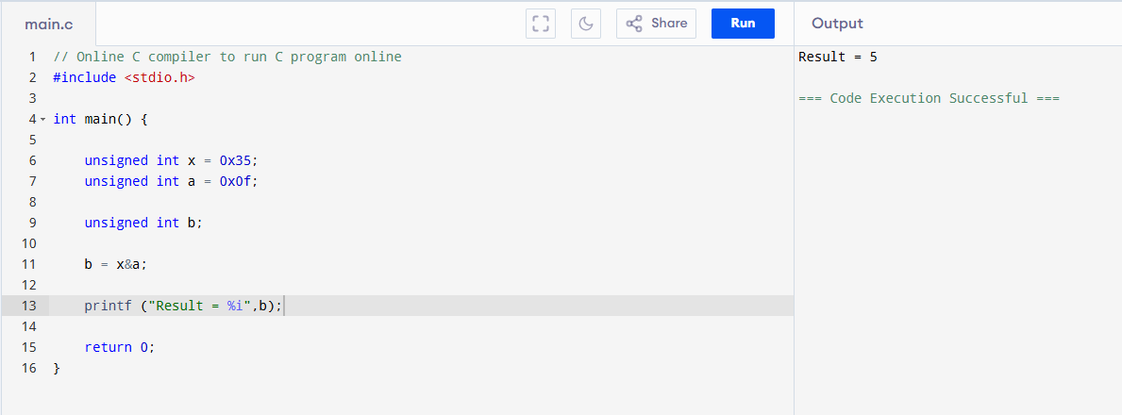

b. Toggle bit #5
Code:
#include <stdio.h>

int main() {

unsigned int x = 0x05;
unsigned int a = (1<<5);
unsigned int b= x^a;
printf ("Result = %x",b);

return 0;
}
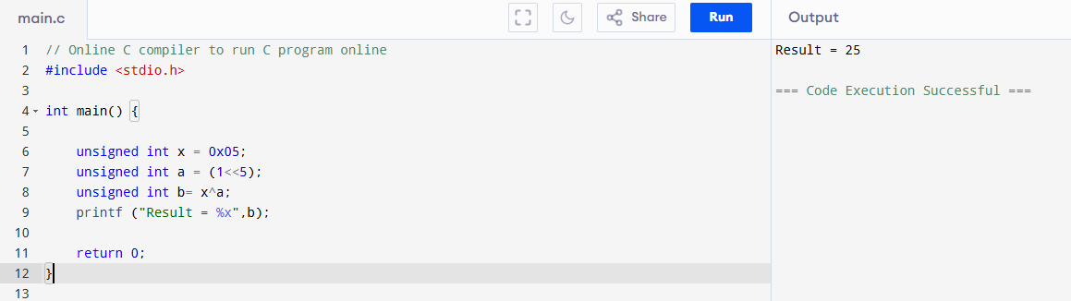

c. Set bit # 5 and clear 6
Code:
#include <stdio.h>

int main() {

unsigned int x = 0x20;
unsigned int a = (1<<5);
unsigned int b= x | a;
unsigned int c =(1<<6);
c =~c;
b = b&c;
printf ("Result = %x",b);

return 0;
}
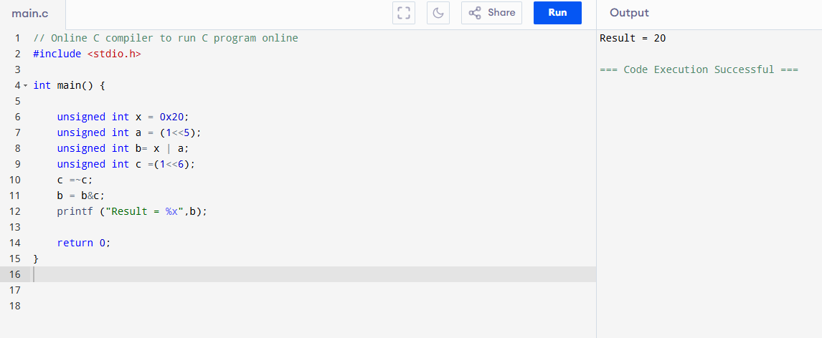

EXERCISE - 2:

Write a C statement to declare a 32-bit unsigned integer using C99 data types and set its bits30-28 to value “6” using compound operators. Try to do this task in two steps only.

Code:
#include <stdio.h>
#include <stdint.h>

int main() {

uint32_t b = 0x11111111;
b &= ~(1<<28);
b |= (0x6<<28);
printf ("Result = %x",b);

return 0;
}

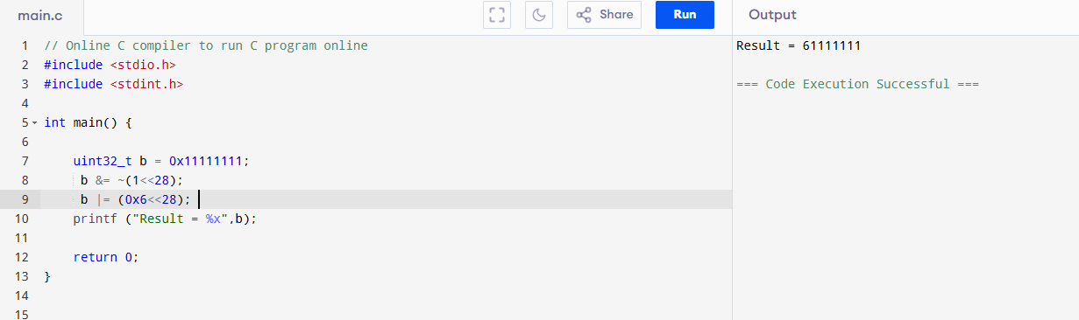

EXERCISE - 3:

Write output of following code

d. 0x2F & 0Xf0
e. 0x27<<4
f. x=0x56; x=x&~ (3<<2);
g. x=0x78; x= (x&~ (7<<4)) | (5<<4);

Code:
#include <stdio.h>
#include <stdint.h>

int main() {

unsigned int d = 0x2F & 0Xf0;
printf ("Result of d Part = %x",d);

unsigned int e = 0x27<<4 ;
printf ("\n Result of e part = %x",e);

unsigned int f =0x56;
f = f &~ (3<<2);
printf ("\n Result of f part = %x",f);

unsigned int g =0x78;
g = (g &~ (7<<4)) | (5<<4);
printf ("\n Result of g part = %x",g);

return 0;
}

